WORLD ENVIRONMENT DAY – 05.06.2026
(Inspired by Nature. For Climate. For Our Future)
In DHANALAKSHMI SRINIVASAN AGRICULTURE COLLEGE, we have celebrated the “world environment day” on 05.06.2026 in our auditorium. Various competitions and activities were conducted with the objective of World Environment Day, to promote awareness about environmental sustainability. Students actively participated in different competitions like essay writing, poetry writing and drawings and showcased their talents with great enthusiasm and dedication. In order to celebrate the event, we had ceremony in the auditorium. The winners were appreciated and awarded certificates and prizes in recognition of their active performances.
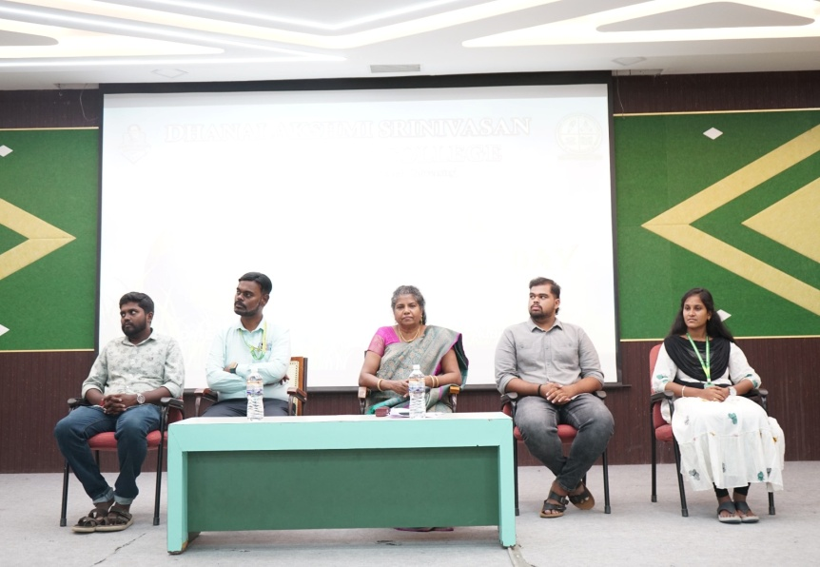
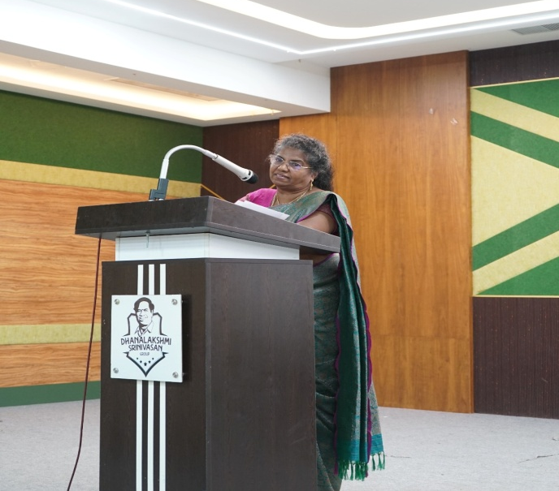
A special highlight of the event was the speech delivered by our DSAC Principal Dr.Irine Vedhamoni, she emphasized the importance of current environmental pollution and its impact on environment and agricultural food production. She also discussed management strategies among the students. The speech encouraged students to combat the pollution. The event concluded with a vote of thanks, expressing gratitude to the organizers, students and faculty members. Overall the program was informative and valuable among the students.

